**Simple Swagger Application Setup- Basic to understand**

Run the application:  
1. Click java file as “Java application” 🡪Application.java  
2. Open chrome and type🡪 [**http://localhost:8080/swagger-ui.html**](http://localhost:8080/swagger-ui.html)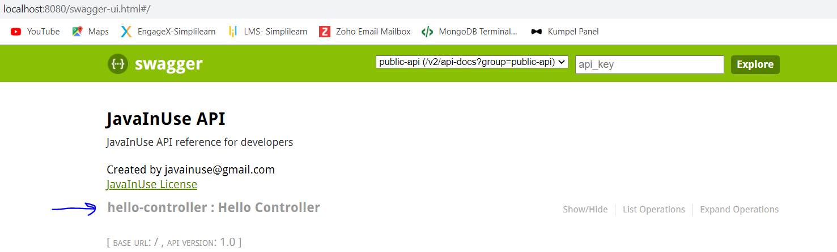  
3. Click 🡪 “hello-controller”  
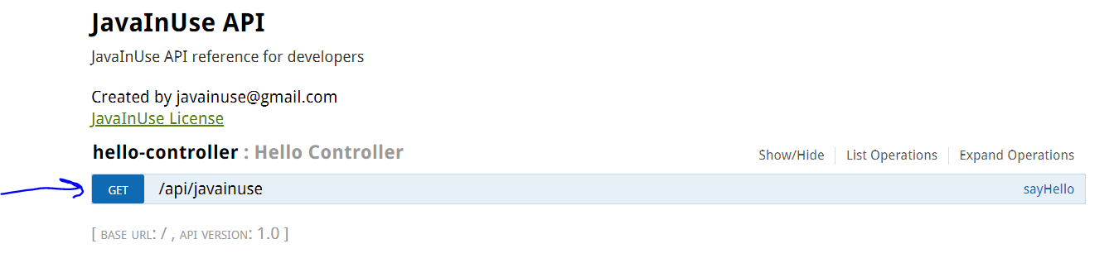  
  
4. Click 🡪 /api/javainuse  
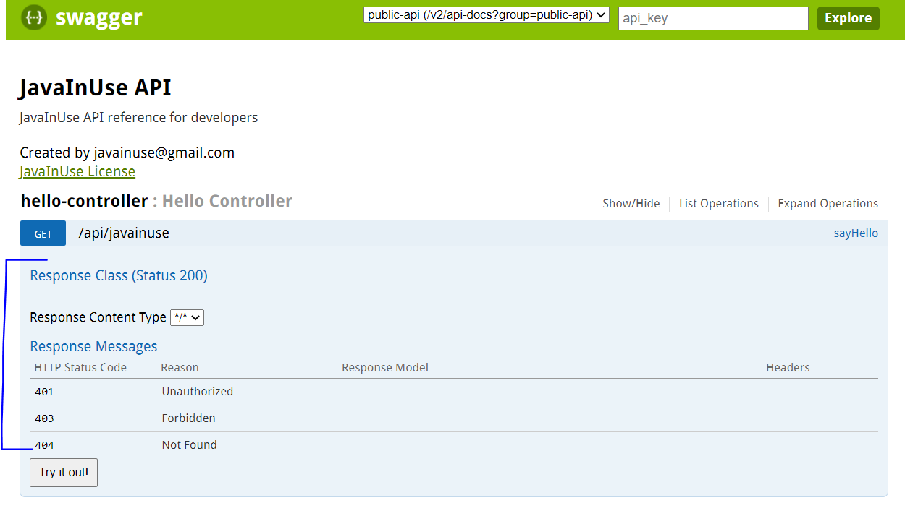

5. Click 🡪 “Try it out” button  
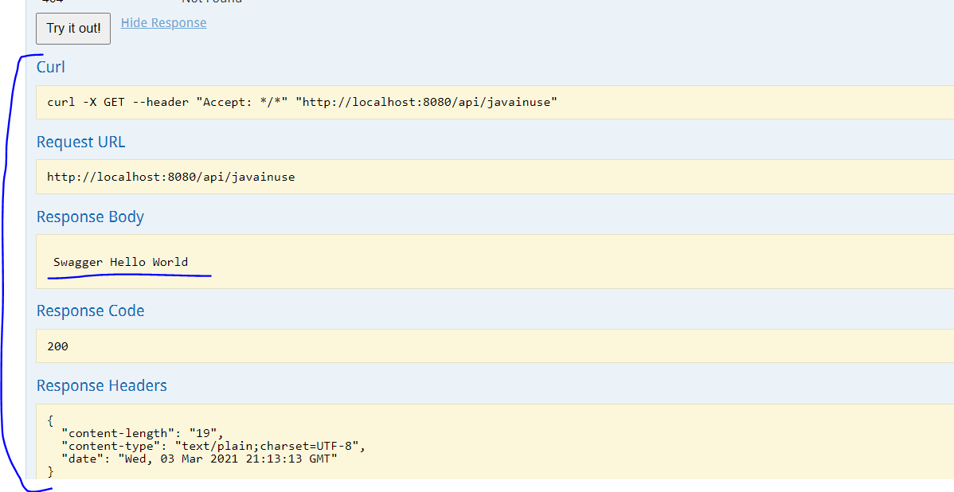

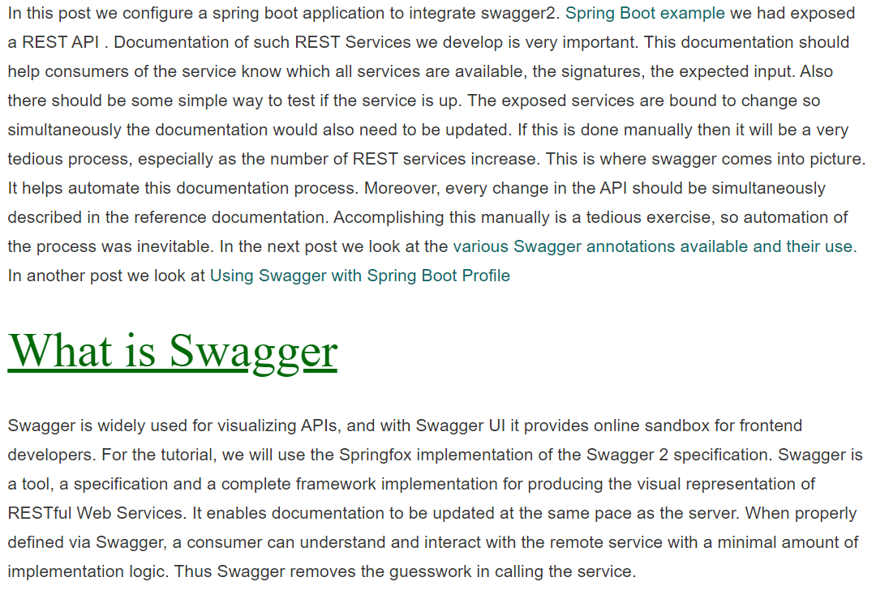

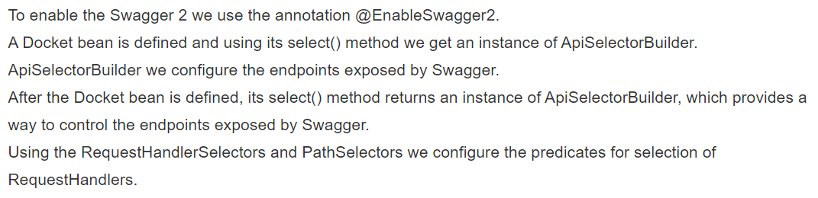

**Advanced Swagger Example:**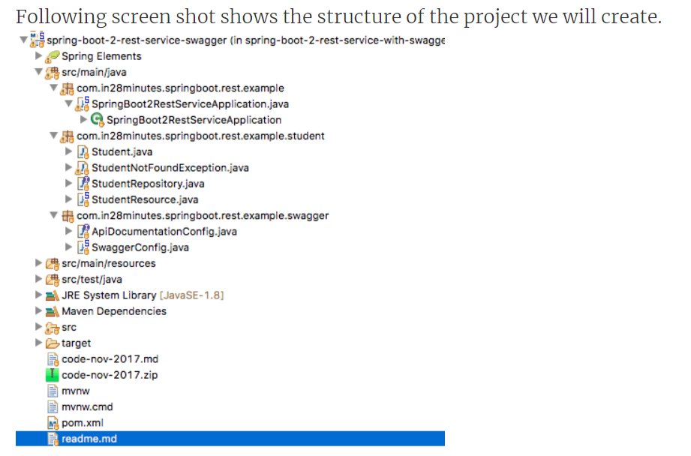

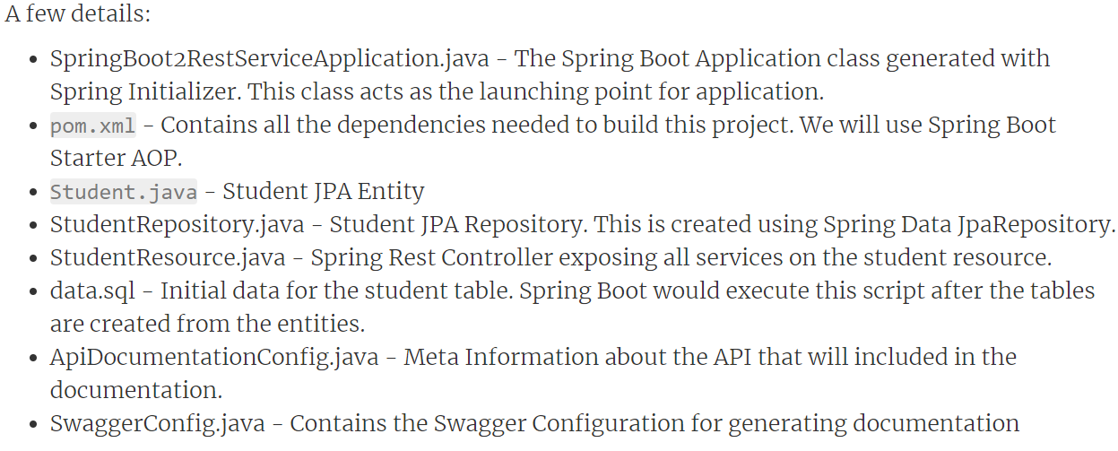

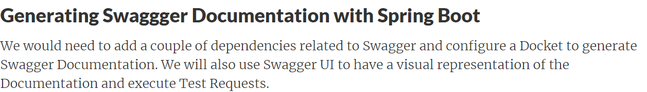

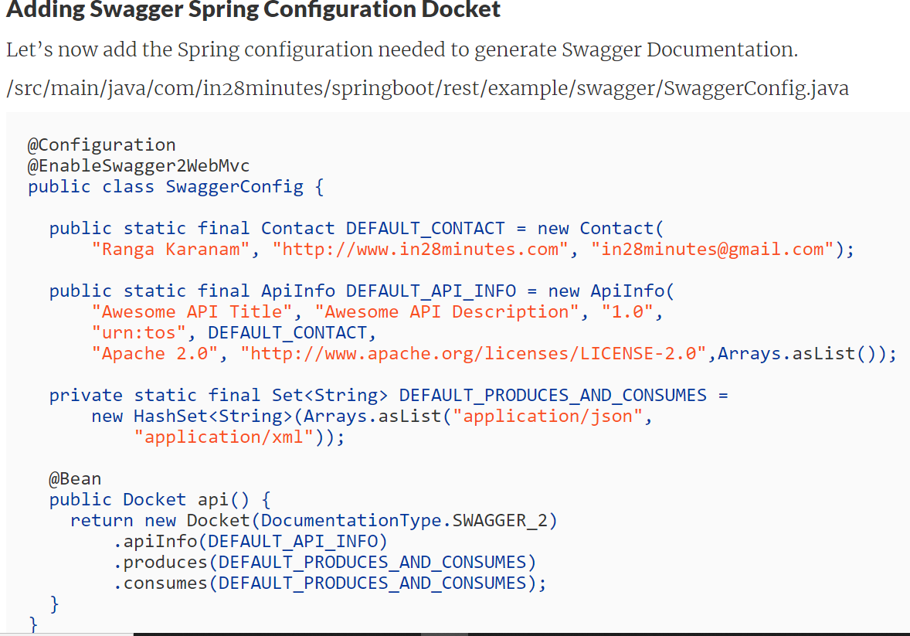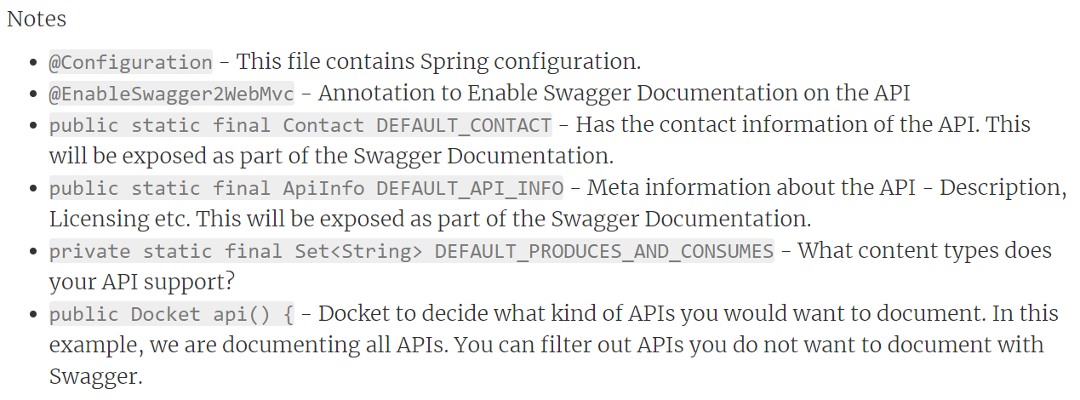

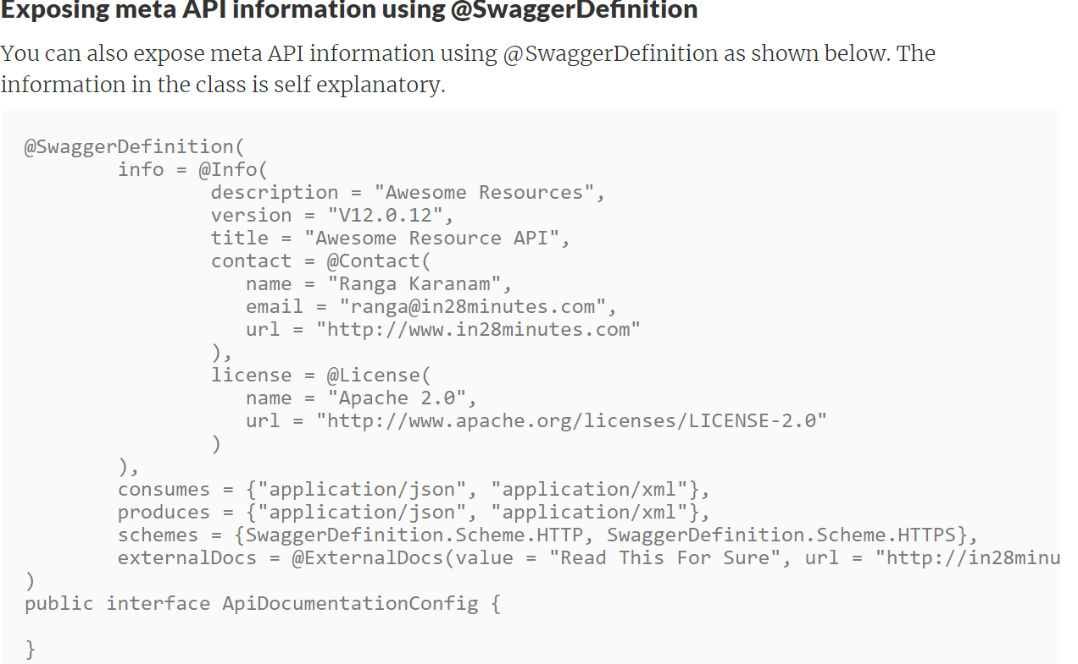

**URL:-**<http://localhost:8080/swagger-ui/index.html>